Asia-China-Coin-3 -Spade-Flat Handle-Square Foot-H 3.414-R 7

王氏方足布."王氏"place of Wei Nation.Now it is the West of JiYuan City,HeNan Province.This one was was found in the capital of ZhouDy.

length 4.3CM/1.69Inches, width 2.7CM/1.06Inches

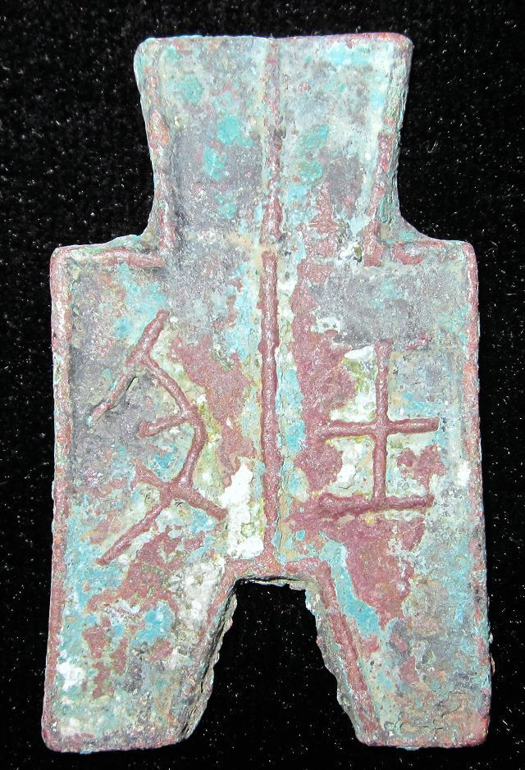

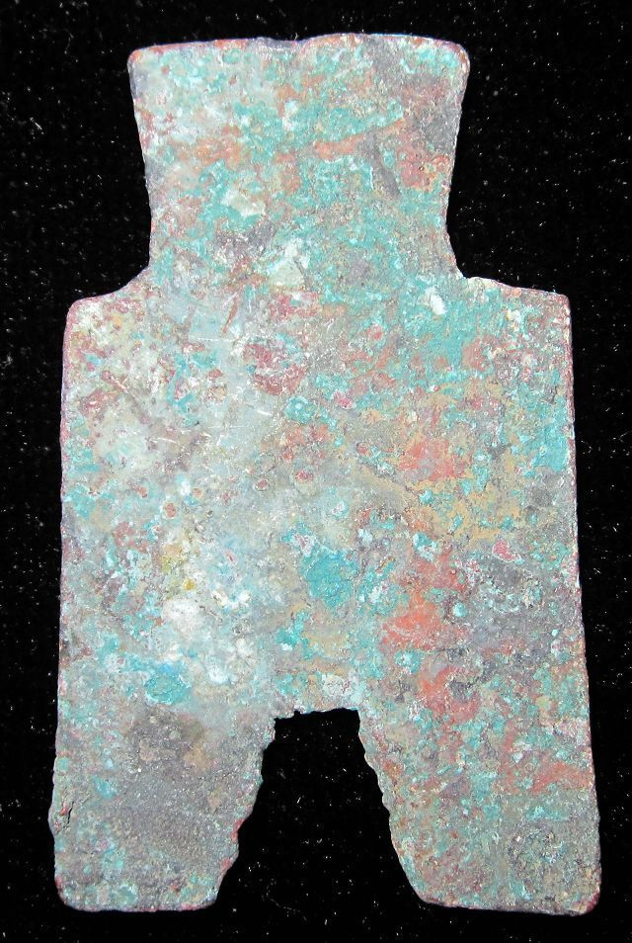 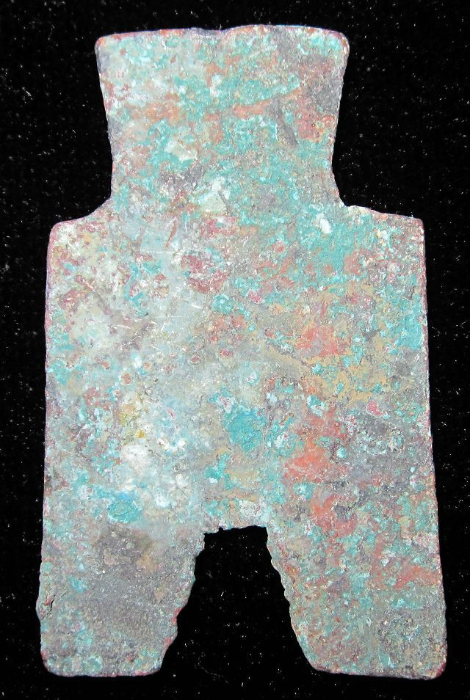

|  |  |  |
| --- | --- | --- |
| VINTAGEWarringStatesPeriod WEI NATION CITY MINT MONEY BRONZE SPADE COIN王氏方足布1.7" [See original listing](http://www.ebay.com/itm/VINTAGEWarringStatesPeriod-WEI-NATION-CITY-MINT-MONEY-BRONZE-SPADE-COIN-1-7-/251416365979?nma=true&si=5L4Tlo08dyY9pQflhUEb6fWvMTI%253D&orig_cvip=true&rt=nc&_trksid=p2047675.l2557) | | |
| |  |  | | --- | --- | | |  | | --- | |  | | |  |  |
|  |  |
| Item condition:  --not specified  “Rust on the body,Museum quality” |  |
| Ended:  Jan 09, 2014 07:54:20 PST |  |
| Winning bid:  US $78.00  [ [7 bids](http://offer.ebay.com/ws/eBayISAPI.dll?ViewBids&_trksid=p2047675.l2565&rt=nc&item=251416365979) ] |  |
| Shipping:  $10.00 Economy Shipping from outside US |  |
| Item location:  GuangZhou, China |  |
| Seller:  [bcculture](http://myworld.ebay.com/bcculture?_trksid=p2047675.l2559) ([84](http://feedback.ebay.com/ws/eBayISAPI.dll?ViewFeedback&userid=bcculture&iid=251416365979&ssPageName=VIP:feedback&ftab=FeedbackAsSeller&rt=nc&_trksid=p2047675.l2560) )  |  [Seller's other items](http://www.ebay.com/sch/bcculture/m.html?item=251416365979&rt=nc&_trksid=p2047675.l2562) |  |